
Karachi Institute of Economics & Technology

Department of Computer Science and IT
Course Project Proposal Form

Sno. | Stud. ID | Names | Course Name
1 | 9134 | Hammad Abid | Introduction To Data Science
2 | 9536 | Muhammad Faraz | Introduction To Data Science
3 | 9198 | Kashaf Lodhi | Introduction To Data Science

Project Title: Job market in Pakistan

- Motivation:
There is a huge communication gap between the market and the educational institute’s regarding jobs. We have analyzed this problem and make a solution using data science to let people know we can find out what Pakistan is hiring for and what's the need to guide our youth for available job options. Also, if we can link it to universities dataset of what they are teaching and what the market needs?

- Overview

  - Description of the Project
There is a huge shortage for good datasets on Pakistan's job market. This kind of data is always needed for new startups, learning and development companies, education consultants, universities and policy makers. This is first of its kind datasets out there.
  - Background of the Project
The dataset contains close to 7,000 job openings in Pakistan from December 2019 to March 2021. It contains job title, department, required experience in years, data posted, city of job, nature of job (full-time, parttime etc.), job description and the premium label of the job post.
- Functional Features

- Start with the most significant feature.
Data Analysis using EDA and Data Wrangling. Here are some of data Wrangling techniques that we are follow during our development of this project.
- DISCOVERING
- STRUCTURING
- CLEANING
- ENRICHING
- VALIDATING
- PUBLISHING

- Second most significant feature.
Data Prediction Using Machine Learning.
Using Machine Learning we can build the model and trained this model so it can perform prediction. We can use different algorithms for that one of them is linear regression.

- Project Planning

Every team member will perform all the operations that are necessary required for the completion of this project.
- First, we do data wrangling which means that every team member should do this step in a team. Each team member will perform this technique on the dataset on his own pc.
- After wrangling we all should do the same with the data prediction. Will be using machine learning for that.
- Now we have 3 mini project’s which means everyone should done this above two steps on his own pc’s. Now will combine this and make a complete one project which will provide the best results.

- Hardware and Software Requirements
Required Hardware:
- Laptop
Software Required:
- Anaconda
- Python
- OS(Windows)

- Diagrammatic Representation of the Overall System
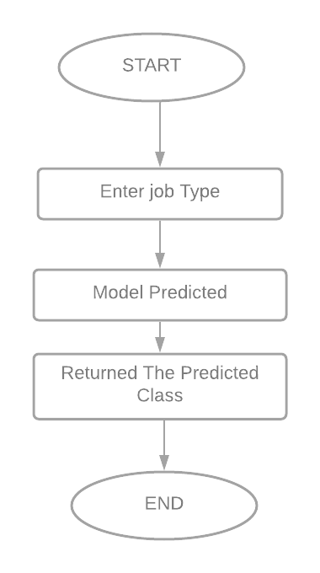
- Expected Duration/Hours

The Minimum duration/hours requirement for the project is 150 hours. You have to justify your project duration requirement in point 4

- What is your current level of expertise in the languages/tools/techniques you use?
- Faraz: Expert
- Hammad: Beginner
- Kashaf: Beginner

Student’s Signature: ______________ Date: ________________

